

**Canteen Ordering System for Unilever**

**SIMPLILEARN PC BA - CBAP CERTIFICATION PROJECT – 1**

Submitted By:

**Rohan Maity**

Table of Contents

Introduction 2

Business Analysis Core Concept Model (BACCM) 3

Project Tasks 5

1. Stakeholder Identification 5

1.1 Internal and External Stakeholder Classification 5

1.2 Stakeholder Activity Analysis 5

1.3 Stakeholder Onion 7

1.4 RACI Matrix 7

1.5 Stakeholder Matrix 8

2. Problem Statement Identification 10

2.1 Identifying Problem Statement 10

2.2 Fish Bone Diagram 10

3. Objectives of New Canteen Ordering System 11

4. As-Is and Future State Map 12

4.1 As-Is State 12

4.2 Future State 13

5. Scope of the New Canteen Ordering System 14

6. Main Features to be developed 15

7. In-Scope and Out-of-Scope Items 16

8. Activity Diagram 17

9. ER Diagram of the System 18

10. Requirements of the Business 19

10.1 Functional Requirements 19

10.2 Non-Functional Requirements 19

11. Mock Screens for the New Canteen Ordering System 20

# Introduction

Unilever is a British-Dutch-based MNC FMCG company, and its headquarter is located in London, England. Unilever is one of the oldest FMCG companies in the world and as such, its products are available across 190 countries.

In the UK Office of Unilever, 1500 employees are working for the company and are spread across 12 floors. 2 canteens in the office cater to all the employees, and at any given time, each of the canteens can accommodate a maximum of 150 employees. The lunchtime takes place between 12 pm to 1 pm as per the preference of the majority of the employees and this leads to huge rush in the canteen for employees which resulted in wastage of time for the employees as they had to wait for tables to be vacant.

It was found that it took an entire hour for any employee to go and come back from lunch. While it took only 10-15 minutes to eat, 30-35 minutes were spent waiting in queue for collecting their food and getting a vacant table, and 10 minutes were spent going to the canteen and coming back from it using elevators.

Moreover, many employees are unable to get their preferred choice of food from the canteen and wastage of food occurs as the food that does not get purchased is thrown away. To tackle this challenge, a request has been made by the employees to develop a canteen ordering system that would permit canteen users to order their lunch meals online and have the food delivered to their work location at a specified date and time.



**Figure 1: Unilever Logo**

# Business Analysis Core Concept Model (BACCM)

The Business Analysis Core Concept Model or BACCM is a business analysis conceptual framework used to evaluate six core concepts of any given business analysis project or task.

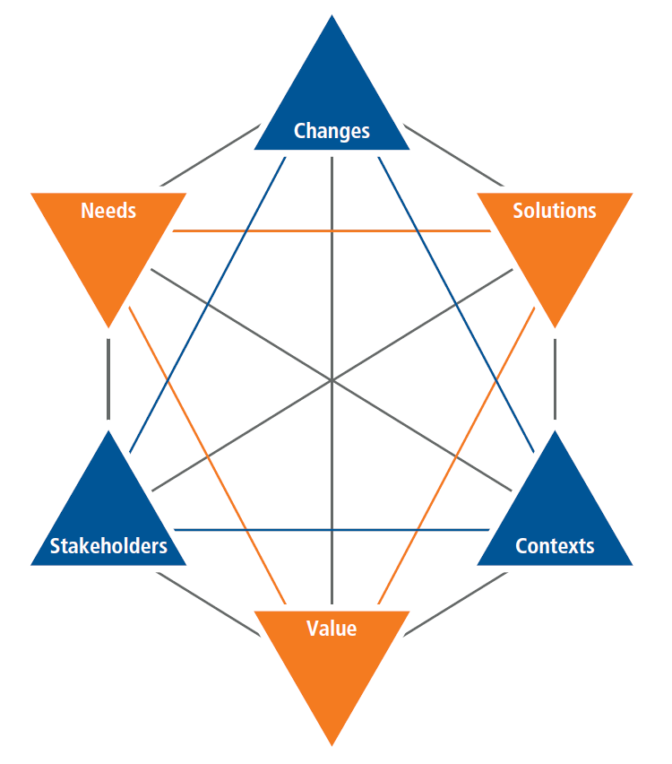

**Figure 2: BACCM Model**

In the context of the problem faced by the employees in the UK office of Unilever, the application of the BACCM model will yield:

|  |  |
| --- | --- |
| **BACCM** | |
| **Need** | * Wastage of time for the employees as it takes an entire hour for any employee to go and come back from lunch with 10-15 minutes to eat, 10 minutes to go to the canteen and come back to work, and 30-35 minutes to wait in queue for collecting food. * Employees are unable to get their preferred choice of food from the canteen. * Wastage of food occurs as the food that does not get purchased is thrown away. |
| **Context** | * 2 canteens in the office which cater to all 1500 employees of the office but can only accommodate a total of 300 employees at a time with lunch time taking place between 12 pm to 1 pm. * This leads to high operating costs of the canteen and reduced productive work time of employees. |
| **Change** | * Switching from a traditional offline canteen ordering system to an online-based flexible canteen ordering system for the office employees. |
| **Solution** | * The development of a new online canteen ordering system to allow an employee of the office to order their lunch meals online and have the food delivered to their work location at a specified date and time while reducing the canteen operating costs due to reduced labor work. * Web-based login and ordering system will permit employees to order in advance the specific lunch meals they need while increasing the employees’ productive work time. * A feedback system to take feedback from the employees will help to improve and enhance the canteen ordering system and reduce the wastage of food. |
| **Stakeholder** | * **Internal Stakeholders:** Domain SME, Implementation SME, Operational Support, Tester, and Project Manager. * **External Stakeholders:** Employees, Chefs, Canteen Manager, Delivery Boy, Unilever Management, Inventory Suppliers, Payroll Administrator or Regulator. * **Business Analyst** |
| **Value** | * Reduction of canteen operating costs. * Reduction of food wastage. * Enhancement of employee productive work time. * Increase in efficiency for canteen management. * Increase in productivity and efficiency for Unilever’s UK office as a whole. |

**Table 1: BACCM Core Concepts for Unilever Office Canteen System**

# Project Tasks

## 1. Stakeholder Identification

### 1.1 Internal and External Stakeholder Classification

The internal and external stakeholders for the new Canteen Ordering System for Unilever are:

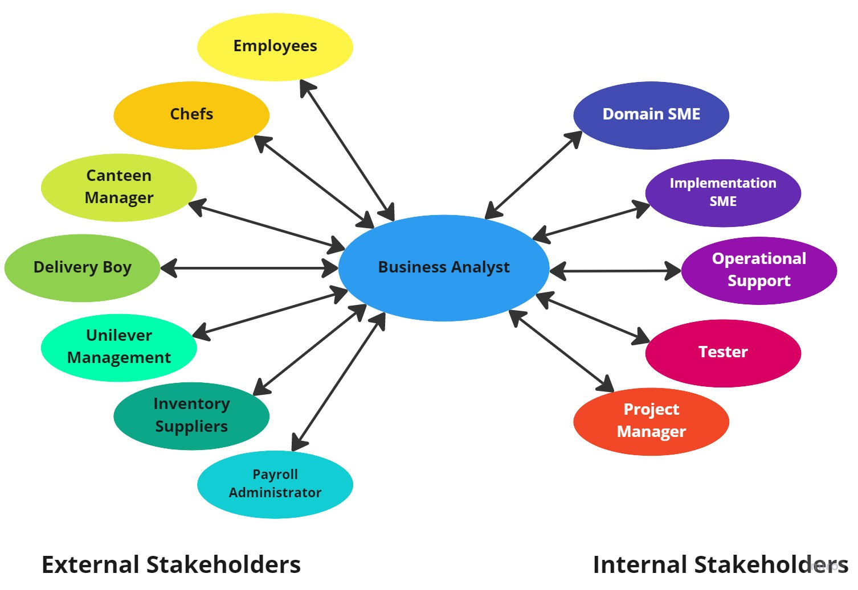

**Figure 3: Stakeholder Classifications**

### 1.2 Stakeholder Activity Analysis

The stakeholders and their activities for the New Canteen Ordering System for Unilever are:

|  |  |
| --- | --- |
| **Actor** | **What they can do on the Software Created** |
| **Employees** | * Log in to the online system and place an order for their lunch meals from the menu items available. * Provide date and time as well as workstation location in the office building for food delivery. * Provide feedback regarding food availability and delivery, delivery service efficiency, and suggestions for improvements. |
| **Chefs** | * Preparation of food as per the orders submitted by the employees. |
| **Canteen Manager** | * Create and update the menu items and delete food items unavailable in the canteen. * Read the lunch items ordered by the employees using the software and assign the items to the chefs. * Monitoring the inventory of food ingredients and assessing which are running low in stock. * Place a request to the delivery boy for delivery of ordered meals to the employees' workstations at the specified dates and times. |
| **Delivery Boy** | * Get food delivery information from the canteen manager. * Delivering the ordered lunch meals to the employees' workstations at the specified dates and times. * Closing the order for successful delivery once delivery is made. |
| **Unilever Management** | * Assess the feedback from employees given on the system and take suitable actions. |
| **Inventory Suppliers** | * Takes orders for food ingredients from the canteen manager and delivers them to the canteens. |
| **Payroll Administrator** | * Account for the total cost incurred by each of the employees for their lunch meals each month and deduct it from their salary at the end of the month. |
| **Business Analyst** | * Engage with the internal and external stakeholders. * Understand the specific project requirements. * Create BA deliverables and essential documents. |
| **Domain SME** | * Provide inputs on the functional developments of the system. |
| **Implementation SME** | * Take inputs from the internal stakeholders and business analyst. * Develop the online canteen order system software application. |
| **Operational Support** | * Provide customer care support for the employees. * Handle user interface (UI) and provide support for backend development requests. |
| **Tester** | * Perform quality analysis on the system for identifying any bugs or issues. * Verify the functionality of the system before its release for usage. |
| **Project Manager** | * Take actions to help guide the project to completion efficiently and effectively. * Guide the internal stakeholders for the development and successful release of the system. |

**Table 2: Stakeholders and their Activities in the System**

### 1.3 Stakeholder Onion

The Stakeholder Onion is a diagram that helps to highlight the relationship of the stakeholders with the project goals. In the context of the project of the New Canteen Ordering System for Unilever, the Stakeholder Onion will be:

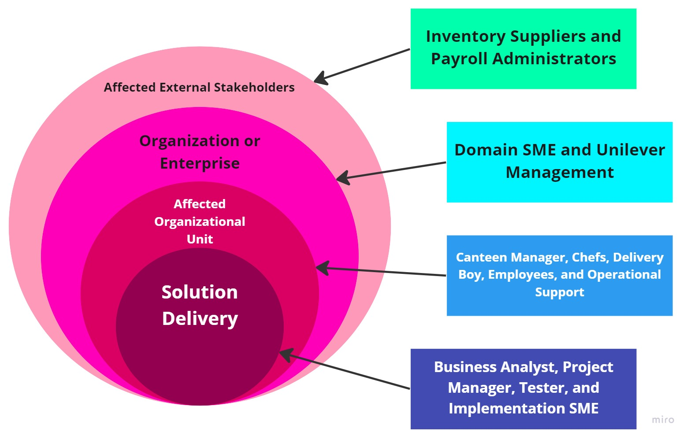

**Figure 4: Stakeholder Onion**

### 1.4 RACI Matrix

The RACI Matrix is a form of stakeholder analysis matrix that categorizes the responsibilities of the stakeholders in a project into 4 different types. These are:

* **Responsible (R):** The stakeholder who will be performing the work on the task.
* **Accountable (A):** The stakeholder who will be held accountable for the successful completion of the task and is the decision-making individual with only one stakeholder being designated this responsibility type.
* **Consulted (C):** The stakeholder who will be asked for or consulted regarding inputs, opinions, information, and advice on the tasks and is generally designated to the subject matter experts (SMEs).
* **Informed (I):** The stakeholder who will be kept updated or notified of the task and its outcomes where information flows in one way and is different from consulted where information flows two-way.

In the context of the project of the New Canteen Ordering System for Unilever, the RACI Matrix will be:

|  |  |  |  |  |
| --- | --- | --- | --- | --- |
| **Stakeholders** | **Responsible** | **Accountable** | **Consulted** | **Informed** |
| **Employees** |  |  |  | **I** |
| **Chefs** |  |  |  | **I** |
| **Canteen Manager** | **R** |  |  | **I** |
| **Delivery Boy** |  |  |  | **I** |
| **Unilever Management** |  |  |  | **I** |
| **Inventory Suppliers** |  |  |  | **I** |
| **Payroll Administrator** |  |  |  | **I** |
| **Business Analyst** | **R** |  |  |  |
| **Domain SME** |  |  | **C** |  |
| **Implementation SME** | **R** |  | **C** |  |
| **Operational Support** |  |  | **C** |  |
| **Tester** | **R** |  | **C** | **I** |
| **Project Manager** | **R** | **A** | **C** |  |

**Table 3: RACI Matrix**

### 1.5 Stakeholder Matrix

The stakeholder matrix helps to map the level of stakeholder influence against the level of stakeholder interest. The stakeholder matrix is segregated into 4 quadrants based on the axis of the level of influence and level of impact and these are:

* **High Influence/High Impact:** These stakeholders are to be worked closely with and ensured that they agree with the change while supporting it.
* **High Influence/Low Impact:** These stakeholders are to be engaged and consulted with so that they can be kept satisfied as they have needs that are to be met by the change.
* **Low Influence/High Impact:** These stakeholders are supporters of the change and are to be engaged with for their input and keep them informed about the change.
* **Low Influence/Low Impact:** These stakeholders are kept informed and are monitored as they have no significant influence or impact but should be ensured that their influence does not change.

For the project of the New Canteen Ordering System for Unilever, the Stakeholder Matrix will be:

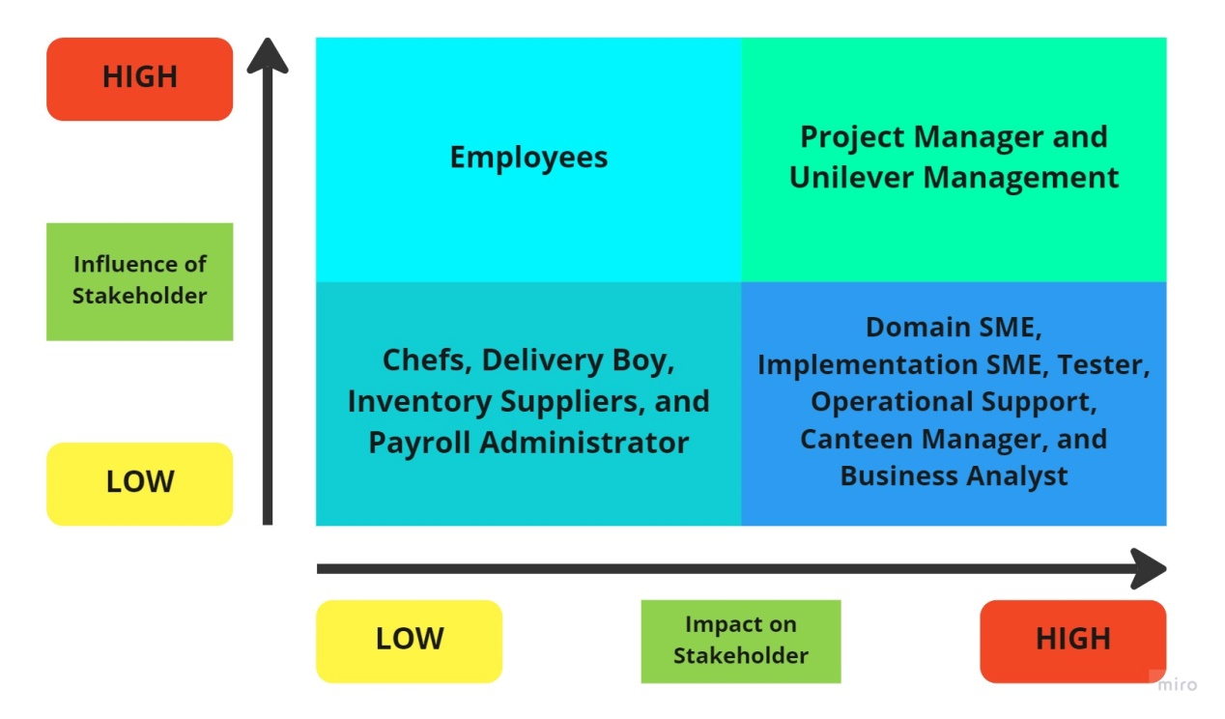

**Figure 5: Stakeholder Matrix**

## 2. Problem Statement Identification

### 2.1 Identifying Problem Statement

The problems given in the context of Unilever are:

* In the UK Office of Unilever, 1500 employees are working for the company and spread across 12 floors with 2 canteens in the office that caters to all the employees, and each of the canteens can accommodate a maximum of 150 employees at once.
* The lunchtime takes place between 12 pm to 1 pm as per the preference of the majority of the employees. This leads to a huge rush in the canteen for employees resulting in time wastage for them as they have to wait for the tables to get vacated.
* It takes an entire hour or 60 minutes for any employee to go and come back from lunch. It takes only 10-15 minutes to eat, but 30-35 minutes are spent waiting in queue for collecting their food and getting a vacant table, while 10 minutes are spent going to the canteen and coming back from it using elevators.
* Many employees are unable to get their preferred choice of food from the canteen.
* Wastage of food occurs as the food that does not get purchased is thrown away.

### 2.2 Fish Bone Diagram

The fishbone diagram is a technique used for root cause analysis to identify the underlying cause of problems and the relationships that exist between those causes. For the project of the New Canteen Ordering System for Unilever, the Fishbone Diagram will be:

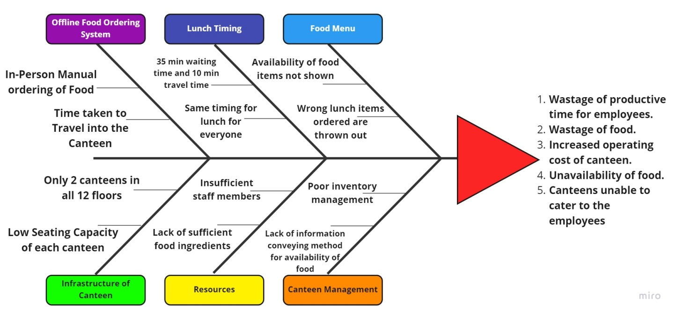

**Figure 6: Fish Bone Diagram**

## 3. Objectives of the New Canteen Ordering System

The objectives of the new Canteen Ordering System for Unilever are:

* Reduce wastage of canteen food by 30% within 6 months of the initial release.
* Reduce the value of food thrown away to less than 15%.
* Reduce canteen operating costs by 15% within 12 months of the initial release.
* Increase the average productive work time of each employee every day by 30 minutes within 3 months of the initial release.
* Development of an automated online food ordering system for employees to order food and deliver it to their work location at a specified date and time while using lesser manpower for its operations.

## 4. As-Is and Future State Map

### 4.1 As-Is State

The current existing canteen system of Unilever can be described using this process flow diagram:

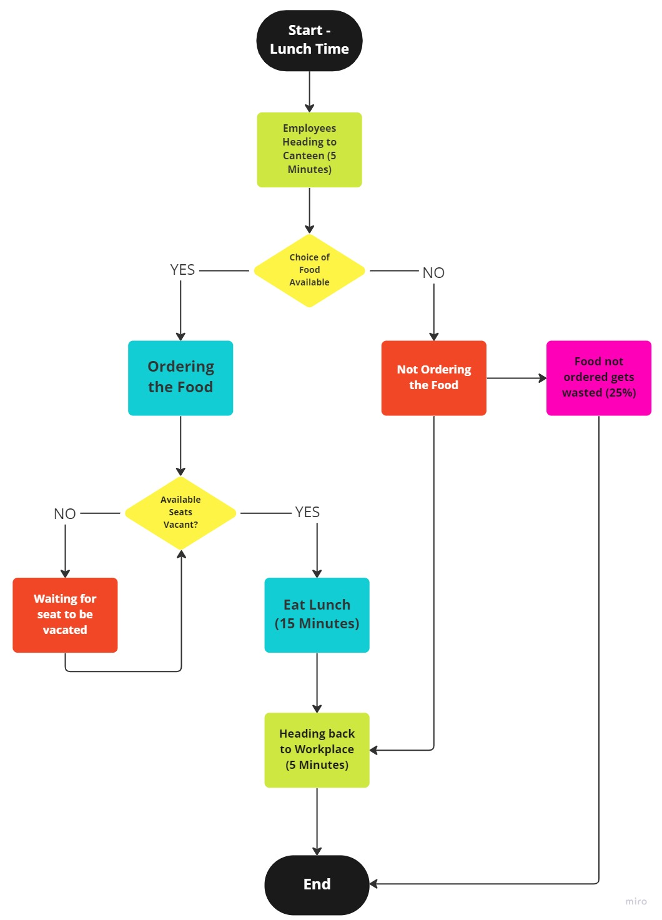

**Figure 7: As-Is State Flow Chart**

### 4.2 Future State

The future state of the canteen system of Unilever can be described using this process flow diagram:

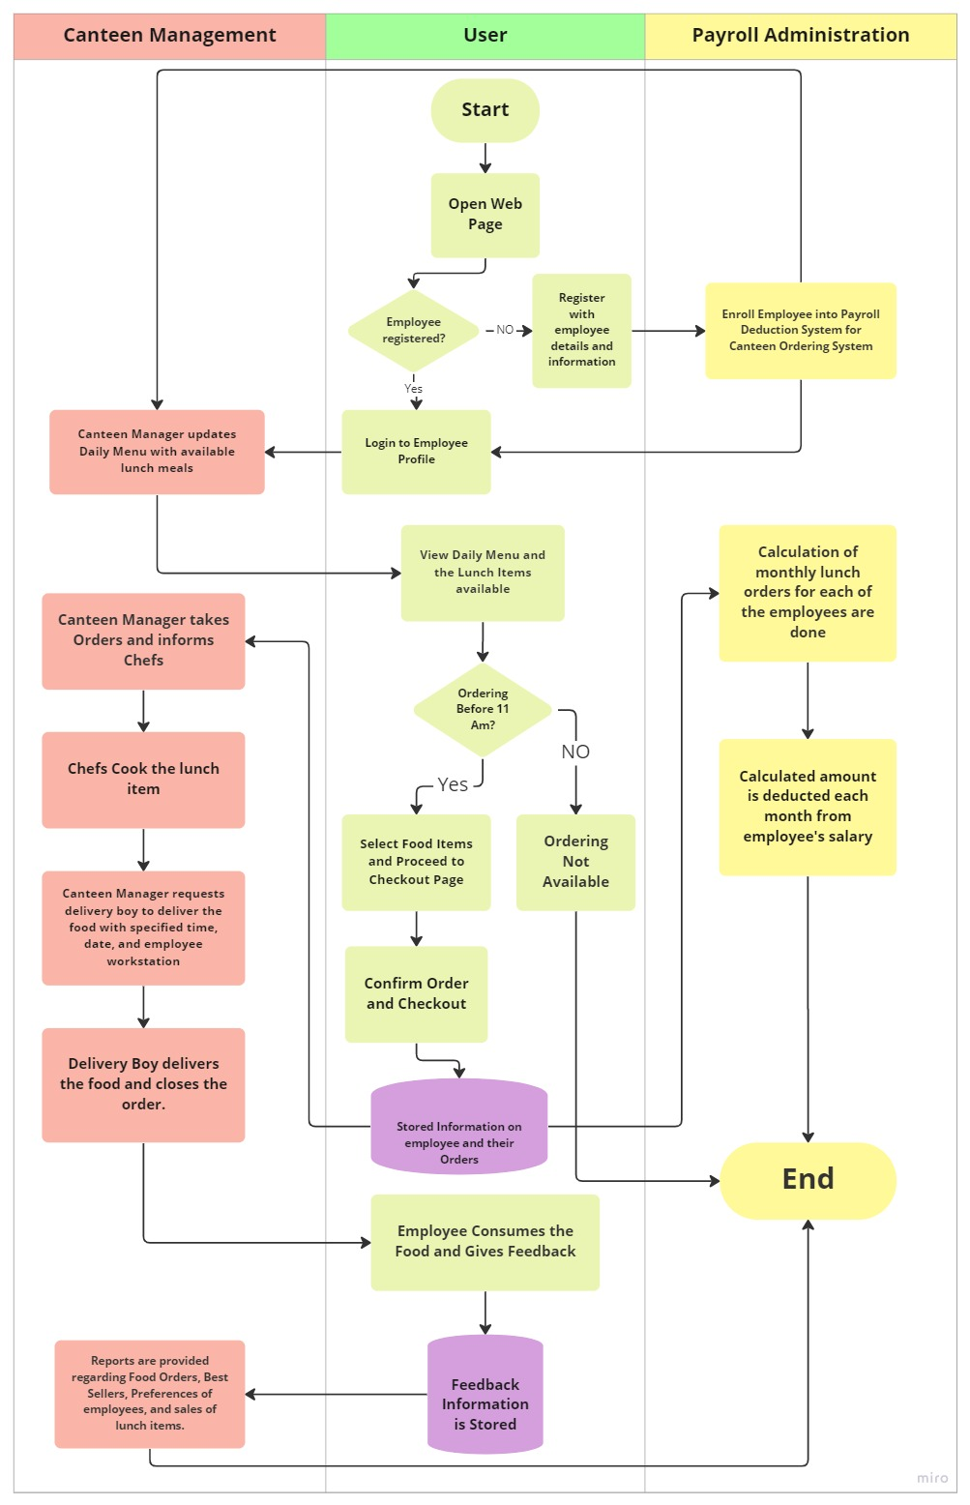

**Figure 8: Future State Flow Chart**

## 5. Context Diagram Scope of the New Canteen Ordering System

The scope of the new canteen ordering system for Unilever can be illustrated using the context diagram:

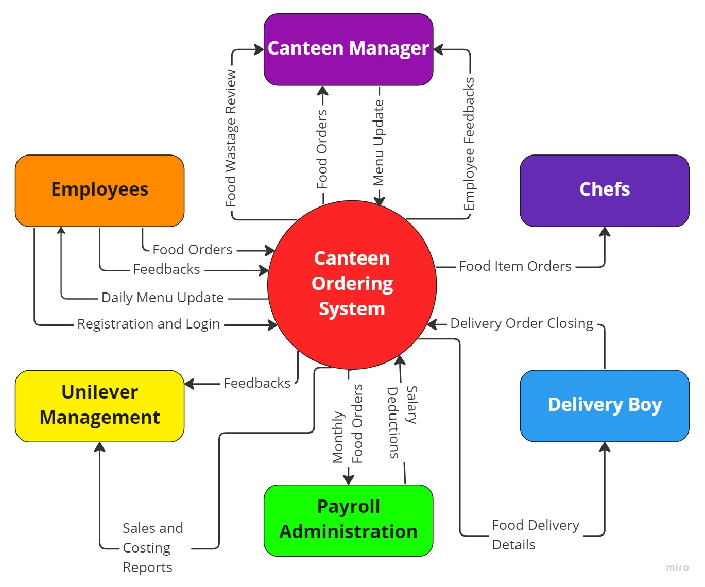

**Figure 9: Context Diagram of COS**

## 6. Main Features to be developed

The main features that are needed to be developed for the new canteen ordering system for Unilever:

* Online website application as well as a mobile application (compatible with Android, iOS, and Windows Mobile OS) with a user-friendly interface to be developed.
* Registration and Login ID page for employees to register and sign in.
* Once logged in, the employee will see their profile which will notify them about the menu for available lunch meals as well as any issues or problems.
* The employee can place an order for whatever lunch meals they want in advance and before 11:00 am while specifying the time and date for its delivery at their workstation.
* Once an order has been made, employees will be redirected to the payment system where they will confirm their payment with the Payroll Administrator.
* Allow employees to track their order once it is picked up by the delivery boy.
* Allow employees to raise tickets and delivery requests in case of issues.
* Allow employees to have access to operational support for getting assistance as well as having any queries or problems resolved regarding the canteen ordering system.
* Allow employees to provide feedback and suggestions for improvement.
* Allow the canteen manager to check the orders placed and relay them to the chefs in the canteens.
* Allow the canteen manager to create and update the menu items and delete food items from the menu that are temporarily unavailable in the canteen.
* Allow the delivery boy to confirm the delivery order and provide the location and time for the food delivery.
* Allow Unilever management to assess the feedback from employees given on the system.
* Allow the payroll administrator to assess the spending for lunch meals of each employee in the office.
* Generate automated reports for sales, popularity, and forecasting for Unilever management to take action.

## 7. In-Scope and Out-of-Scope Items

The in-scope items and the out-of-scope items for the new canteen ordering system software for Unilever are:

|  |  |
| --- | --- |
| In-Scope | Out-of-Scope |
| 1. Online Website and Mobile Application | 1. **Timing for lunch** |
| 1. Employee login and registration | 1. **Vendor management and supplier details** |
| 1. Food Menu and Special Offers | 1. **Chef/kitchen management** |
| 1. Feedback Page | 1. **Inventory for food ingredients** |
| 1. Employee and Canteen Staff Details | 1. **Out-of-office deliveries** |
| 1. Payment Security and Options | 1. **Seating capacity for canteens** |
| 1. Delivery timing options |  |
| 1. Delivery tracking system |  |

**Table 4: In-Scope and Out-of-Scope Items**

## 8. Activity Diagram

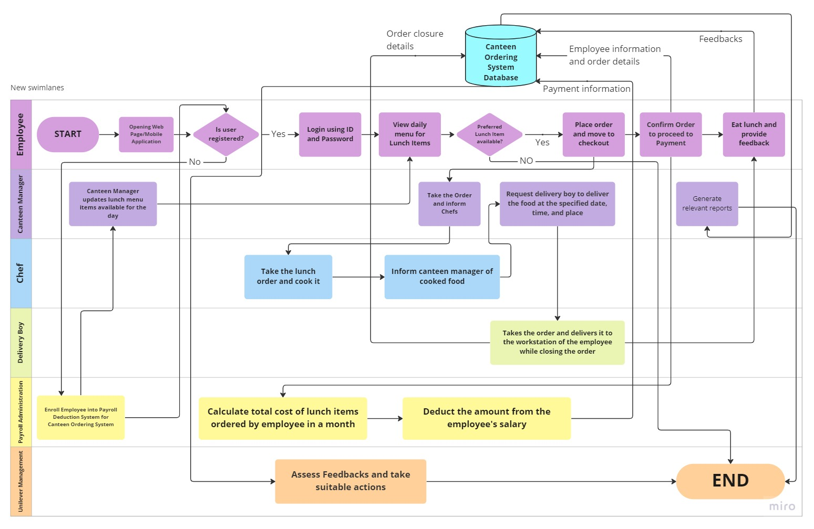**Figure 10: Activity Diagram Flow Chart**

## 9. ER Diagram of the System

The Entity Relationship or ER Diagram for the system will be:

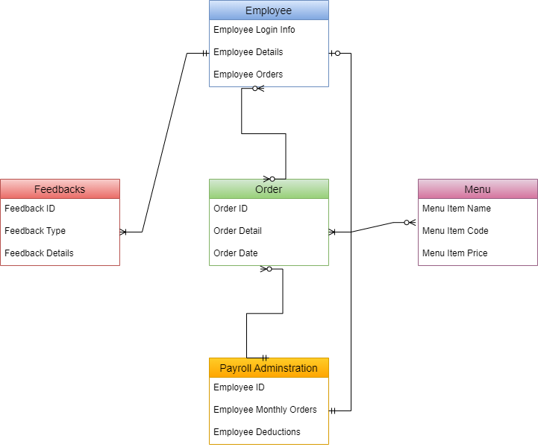

**Figure 11: Entity Relationship Diagram of the System**

## 10. Requirements of the Business

### 10.1 Functional Requirements

The functional requirements are:

* Employees should be able to register using their email ID.
* Employees should be able to log in using their ID and password.
* Employees should be able to confirm their orders and make payments.
* Employees should be able to track the delivery of their orders.
* Employees should be able to provide feedback.
* The canteen manager should be able to create, edit, and update menu items every day.
* Payroll Administration should be able to gather payment information for salary deductions.
* The delivery boy should be able to close orders after completing orders.
* The system should be able to generate relevant reports such as sales, best-selling items, popularity, and forecasting.

### 10.2 Non-Functional Requirements

The non-functional requirements are:

* **Availability:** The users should be able to able to access the system whenever they want and order lunch meals before 11 am
* **Compatibility:** The system should be compatible with the management and payroll administration process of the company.
* **Functionality:** The system should be able to provide a simple and friendly graphic user interface for ease of usage by the users and capable of meeting the needs of the external stakeholders.
* **Maintainability:** The system should be developed with Java program and which will help to make it easy to modify and improve it.
* **Reliability:** The system should be reliable to perform ordering lunch items from 1500 users and work 24 hours nonstop without issues, bugs, glitches, or data errors.
* **Scalability:** The system should be able to handle orders from 1500 users.
* **Security:** The system should be secured enough for the payment gateway and prevent hacking.
* **Usability:** The system should be user-friendly and easy to navigate.

## 11. Mock Screens for the New Canteen Ordering System

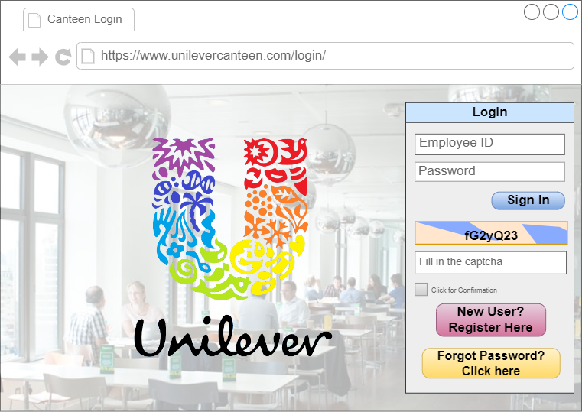

**Figure 12: Canteen Ordering System Website Login Page**

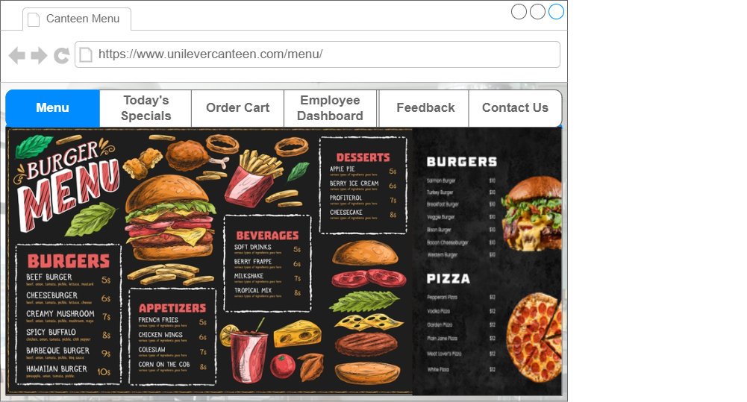

**Figure 13: Canteen Ordering System Website Menu Page**